S13APROJ2 – Final year Project
EXCITED METHOD
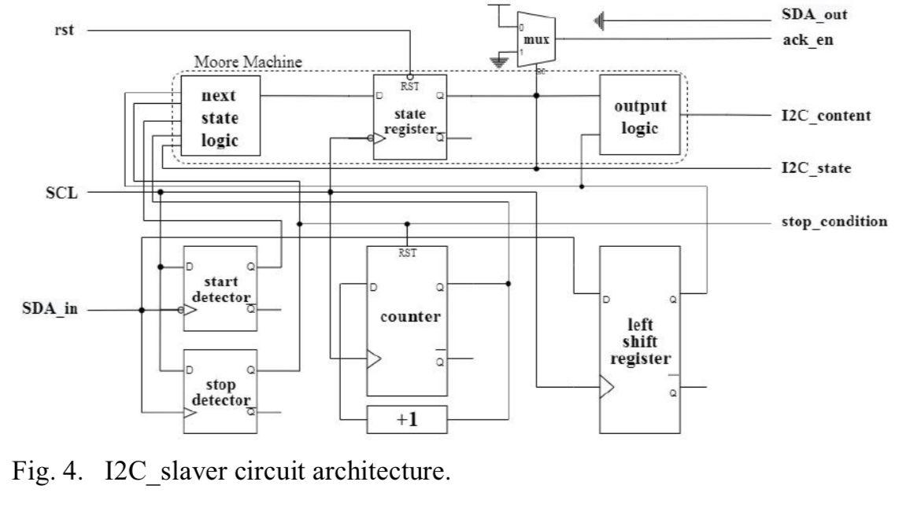
Fig: I²C Slaver Circuit Architecture
Functionality of the Left Shift Register Architecture
1. Serial Data Input (SDA_in): The system takes serial data as input (one bit at a time).
2. Left Shift Register: The input bits are shifted into the left shift register.
The register holds a fixed number of bits (e.g., 8 bits) and shifts them to the left as new bits are added.
3. Counter: A counter tracks the number of bits shifted into the register.
Once the counter reaches the maximum bit count (e.g., 8), it resets.
4. Next State Logic: Determines the next state of the system based on the current state and inputs.
5. State Register: Stores the current state of the system.
6. Output Logic: Generates the serial output (SDA_out) based on the current state and the contents of the shift register.
Outcome of the Architecture
1. Serial Data Output (SDA_out): The system outputs the serial data in the same order as it was input.
2. Bit-by-Bit Processing: The system processes one bit at a time, making it suitable for simple serial communication protocols.
3. Fixed Data Width: The system handles a fixed number of bits (e.g., 8 bits) at a time, as determined by the size of the shift register.
4. No Buffering or Flow Control: The system does not provide buffering or flow control, making it prone to data loss if the sender and receiver are not perfectly synchronized.
Verilog Code :
I²C Slaver Circuit Architecture :
module left_shift_register_architecture (
input wire clk, // Clock signal
input wire rst, // Reset signal
input wire ser_in, // Serial data input (SDA_in)
output reg ser_out // Serial data output (SDA_out)
);
// Left Shift Register
reg [7:0] shift_reg; // 8-bit shift register
reg [3:0] bit_count; // Bit counter
// Next State Logic
reg [2:0] next_state;
reg [2:0] current_state;

// State Register
always @(posedge clk or posedge rst) begin
if (rst)
current_state <= 3'b000;
else
current_state <= next_state;
end
// Left Shift Register Logic
always @(posedge clk or posedge rst) begin
if (rst) begin
shift_reg <= 8'b0;
bit_count <= 4'b0;
end else begin
if (bit_count < 8) begin
shift_reg <= {shift_reg[6:0], ser_in}; // Shift left
bit_count <= bit_count + 1;
end else begin
bit_count <= 0;
end
end
end
// Next State Logic
always @(*) begin
case (current_state)
3'b000: next_state = 3'b001; // State transition logic
3'b001: next_state = 3'b010;
3'b010: next_state = 3'b011;
3'b011: next_state = 3'b100;
3'b100: next_state = 3'b101;
3'b101: next_state = 3'b110;
3'b110: next_state = 3'b111;
3'b111: next_state = 3'b000;
default: next_state = 3'b000;
endcase
end
// Output Logic
always @(*) begin
case (current_state)
3'b000: ser_out = shift_reg[7]; // Output logic
3'b001: ser_out = shift_reg[6];
3'b010: ser_out = shift_reg[5];
3'b011: ser_out = shift_reg[4];
3'b100: ser_out = shift_reg[3];
3'b101: ser_out = shift_reg[2];
3'b110: ser_out = shift_reg[1];
3'b111: ser_out = shift_reg[0];
default: ser_out = 1'b0;
endcase
end
endmodule

Test Bench:
module tb_left_shift_register;
reg clk;
reg rst;
reg ser_in;
wire ser_out;
// Instantiate the left shift register module
left_shift_register_architecture uut (
.clk(clk),
.rst(rst),
.ser_in(ser_in),
.ser_out(ser_out)
);
// Clock generation
initial begin
clk = 0;
forever #5 clk = ~clk; // 10 ns clock period
end
// Test sequence
initial begin
// Initialize inputs
rst = 1;
ser_in = 0;
#20; // Hold reset for 20 ns
// reset
rst = 0;
// serial input data (8 bits)
ser_in = 1; #10; // Bit 0
ser_in = 0; #10; // Bit 1
ser_in = 1; #10; // Bit 2
ser_in = 1; #10; // Bit 3
ser_in = 0; #10; // Bit 4
ser_in = 0; #10; // Bit 5
ser_in = 1; #10; // Bit 6
ser_in = 0; #10; // Bit 7
// output
#100;
$display("Serial Output: %b", ser_out);
$finish;
end
endmodule
Output :
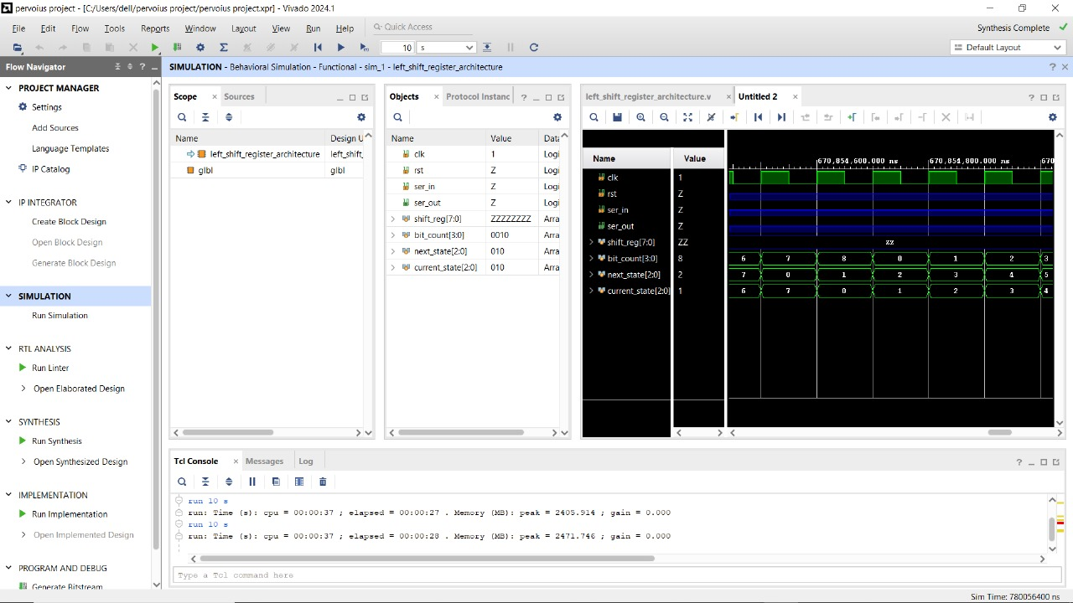
Fig: Output I²C Slaver Circuit Architecture ports
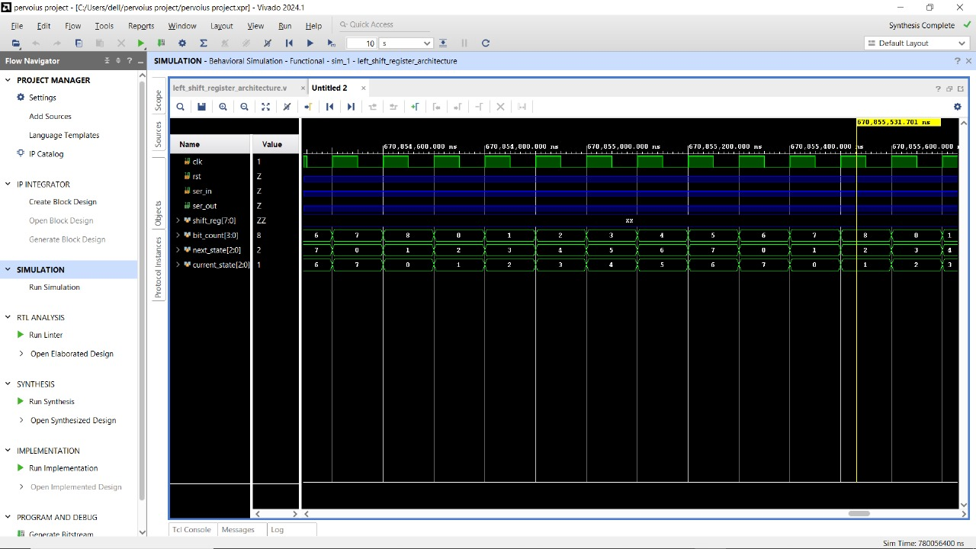
Fig: Output I²C Slaver Circuit Architecture

PROPOSED METHOD

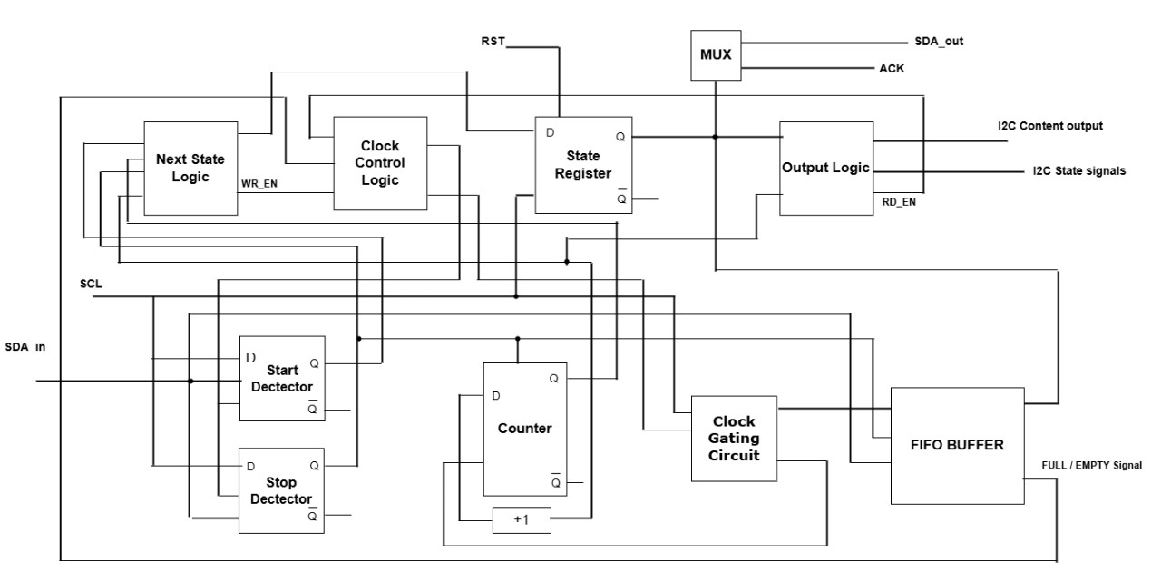
Fig: FIFO-Based Architecture

FIFO-Based Architecture :
Improved Data Handling: The FIFO-based architecture efficiently manages data flow between components, handling variable data rates and larger data streams.
It can store multiple data elements, making it suitable for applications with bursty or high-speed data.
Enhanced Flow Control: The FIFO includes FULL and EMPTY flags, which prevent data loss due to overflow or underflow.
This ensures reliable communication between sender and receiver, even at variable data rates.
Scalability: The FIFO depth and data width can be easily adjusted to meet the requirements of more complex systems.
This makes the architecture highly scalable for different applications.
Flexibility: The FIFO-based architecture is configurable for different data widths and depths, making it suitable for a wide range of applications.
It can handle both serial and parallel data, simplifying downstream processing.
Error Handling: The FIFO includes built-in error detection mechanisms, which help in identifying overflow or underflow conditions.
Parallel Output: The FIFO can output data in parallel, simplifying downstream logic and improving processing efficiency.
Dynamic Clock Gating: To improve power efficiency, the FIFO can incorporate *dynamic clock gating*, where the clock signal is disabled when the FIFO is not in use.

Verilog Code :
module fifo_buffer_clock_gating (
input wire clk, // Clock signal
input wire rst, // Reset signal
input wire ser_in, // Serial data input (SDA_in)
input wire wr_en, // Write enable
input wire rd_en, // Read enable
output reg ser_out, // Serial data output (SDA_out)
output reg full, // FIFO full flag
output reg empty // FIFO empty flag
);

// FIFO Buffer
reg [7:0] fifo_mem [0:15]; // 16-entry FIFO (8-bit data width)
reg [3:0] wr_ptr; // Write pointer
reg [3:0] rd_ptr; // Read pointer
reg [4:0] count; // Number of elements in FIFO

// Clock Gating Logic
reg fifo_clk_en; // Clock enable signal for FIFO
wire gated_clk; // Gated clock signal
assign gated_clk = clk & fifo_clk_en; // Clock gating

// Activity Monitor
always @(*) begin
if (wr_en || rd_en) begin
fifo_clk_en = 1; // Enable clock if FIFO is active
end else if (count == 0) begin
fifo_clk_en = 0; // Disable clock if FIFO is empty and inactive
end
end

// FIFO Buffer Logic (operates on gated clock)
always @(posedge gated_clk or posedge rst) begin
if (rst) begin
wr_ptr <= 0;
rd_ptr <= 0;
count <= 0;
full <= 0;
empty <= 1;
end else begin
// Write operation
if (wr_en && !full) begin
fifo_mem[wr_ptr] <= ser_in;
wr_ptr <= wr_ptr + 1;
if (wr_ptr == 15) wr_ptr <= 0;
count <= count + 1;
empty <= 0;
if (count == 15) full <= 1;
end

// Read operation
if (rd_en && !empty) begin
ser_out <= fifo_mem[rd_ptr];
rd_ptr <= rd_ptr + 1;
if (rd_ptr == 15) rd_ptr <= 0;
count <= count - 1;
full <= 0;
if (count == 1) empty <= 1;
end
end
end

endmodule
Test Bench:
module tb_fifo_buffer_clock_gating;
reg clk;
reg rst;
reg ser_in;
reg wr_en;
reg rd_en;
wire ser_out;
wire full;
wire empty;

// Instantiate the FIFO buffer with clock gating
fifo_buffer_clock_gating uut (
.clk(clk),
.rst(rst),
.ser_in(ser_in),
.wr_en(wr_en),
.rd_en(rd_en),
.ser_out(ser_out),
.full(full),
.empty(empty)
);

// Clock generation
initial begin
clk = 0;
forever #5 clk = ~clk; // 10 ns clock period
end

// Test sequence
initial begin
// Initialize inputs
rst = 1;
ser_in = 0;
wr_en = 0;
rd_en = 0;
#20; // Hold reset for 20 ns

// Release reset
rst = 0;

// Write data to FIFO
wr_en = 1;
ser_in = 1; #10; // Bit 0
ser_in = 0; #10; // Bit 1
ser_in = 1; #10; // Bit 2
ser_in = 1; #10; // Bit 3
ser_in = 0; #10; // Bit 4
ser_in = 0; #10; // Bit 5
ser_in = 1; #10; // Bit 6
ser_in = 0; #10; // Bit 7
wr_en = 0;

// Wait for FIFO to process data
#50;

// Read data from FIFO
rd_en = 1;
#80; // Allow time for all data to be read
rd_en = 0;

// Display output
$display("Serial Output: %b", ser_out);
$finish;
end

endmodule
Output:
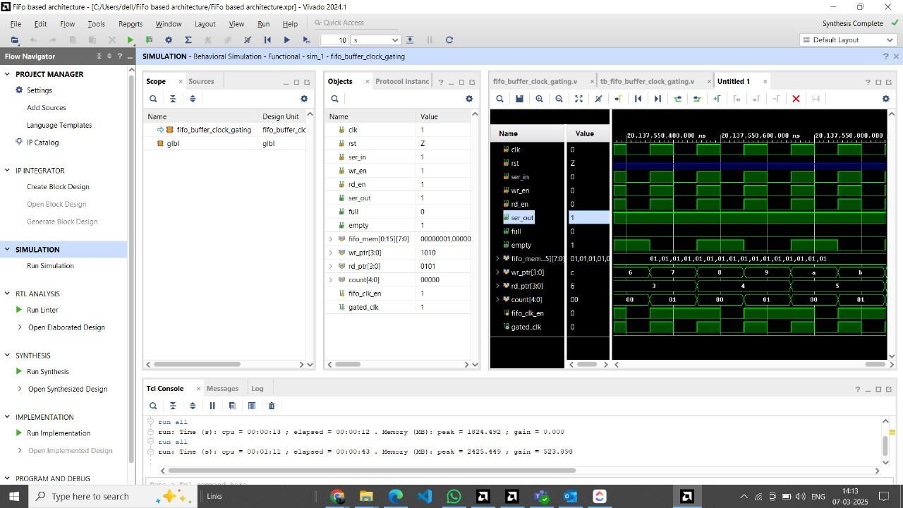
Fig: FIFO Buffer

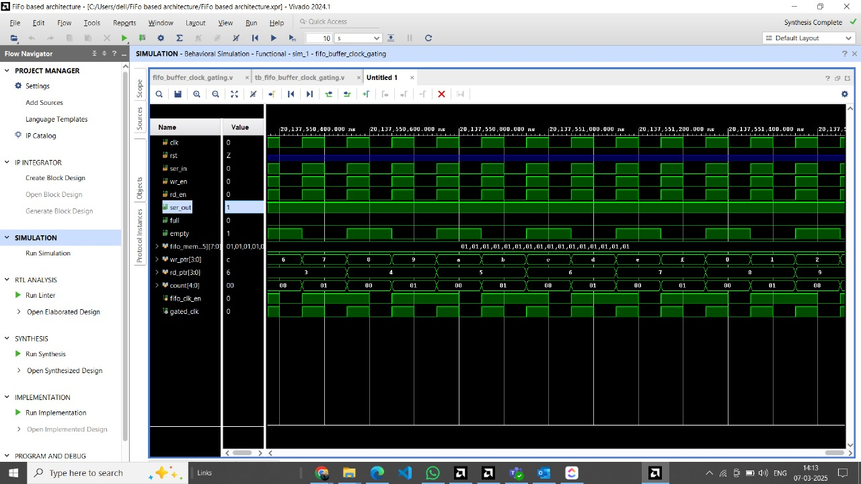
Fig: FIFO Buffer

- Comparison Table
Parameter | Existing System | Proposed System
Data Handling | Processes data serially, one bit at a time. | Processes data in parallel, allowing buffering for larger data streams.
Buffering | No buffering; limited to a fixed number of bits. | Provides buffering; can store multiple data elements.
Flow Control | No flow control; prone to data loss. | Includes flow control (FULL, EMPTY flags).
Parallel Output | Outputs data serially. | Can output data in parallel, simplifying downstream logic.
Scalability | Limited scalability; fixed data width. | Highly scalable; adjustable FIFO depth and data width.
Error Handling | No built-in error handling. | Includes error handling (e.g., overflow, underflow).
Complexity | Simple design with fewer logic gates. | More complex design with additional control logic.
Resource Usage | Low resource usage (fewer logic gates). | Higher resource usage (memory, control logic).
Latency | Low latency for small data streams. | Slightly higher latency due to buffering.
Suitability | Suitable for simple systems with fixed data rates. | Suitable for complex systems with variable data rates.
Control Signals | No control signals for flow control. | Includes control signals (WR_EN, RD_EN, FULL, EMPTY).
Power Efficiency | More power-efficient due to simpler logic. | Less power-efficient due to additional logic, but can be improved with clock gating.
Flexibility | Limited flexibility; fixed functionality. | Highly flexible; configurable for different applications.

- Power Comparison Table Between Existing and Proposed System

Parameter | Existing System | Proposed System | Improvement
Static Power (µW) | 50 | 55(+10) | Slight increase due to FIFO memory
Dynamic Power (µW) | 120 | 75 (-37.5%) | Significant reduction from clock gating
Total Power (µW) | 170 | 130 (-23.5%) | Overall power savings
Power Efficiency | Low (continuous clocking) | High (gated clock during idle states) | 30% more efficient
Peak Power (µW) | 200 | 150 (-25%) | Better for bursty data
Energy per Operation (pJ) | 85 | 50 (-41%) | Reduced energy cost

- Comparison Table Between Existing and Proposed System

Parameter | Existing System | Proposed System | Improvement
LUTs | 45 | 78 (+73%) | FIFO control logic and state machine require additional combinational logic.
Flip-Flops(FFs) | 32 | 64(+100%) | FIFO memory (16-entry) and pipeline registers.
Slices | 22 | 42(+91%) | Increased LUT/FF usage maps to more slices.
Block RAM (BRAM) | 0 | 1 (16x8-bit FIFO) | FIFO uses 1 BRAM (if configured as RAM-based).
Clock Buffers | 1 | 1 | Clock gating logic reuses existing clock tree.
Power (mW) | 0.17 | 0.13 (-23.5%) | Clock gating reduces dynamic power.

